Real Estate Sale of the Century
Unlocking the secret to buying REOs before they hit MLS, creating instant cash by flipping some, and hundreds of thousands down the road with Rent Smart Lease Purchases
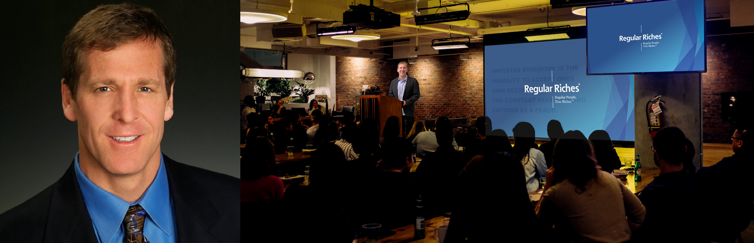
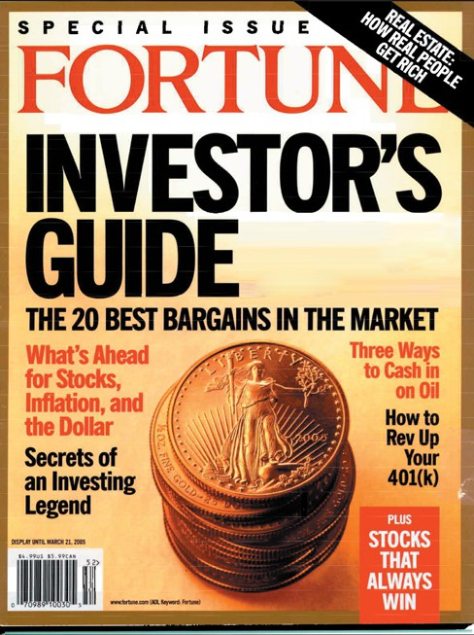
Andy Heller’s Full Day Workshop
YOUR Generation’s #1 Wealth-Building Opportunity
If you’re ready to learn, Andy Heller is ready to teach and share his secrets! So why should you join us?
Fortune Magazine recognizes Andy’s Buy Low, Rent Smart, Sell High model
among the TOP 5 Wealth Building Strategies for Real Estate Investors.

SIGN UP NOW!
HOW TO FIND AND BUY
BANK-OWNED FORECLOSURES FOR PENNIES ON THE DOLLAR!!!
•

•
Turning Ugly and Awful Homes into cash cows
Calculating Your Ceiling Price – How to ensure you never overpay when buying properties!
Finding Pocket Listings… BEFORE anyone else has a chance to buy them.
Learn why successful wholesalers focus on REOs.
•
•
•
•
Rent Smart Lease/Purchase – finding the golden tenants, the envy of other landlords
How to sell for top dollar WITHOUT paying real estate commissions
The SIX profit sources of Andy’s
Buy Low, Rent Smart, Sell High model
•
….and so much more!
Edit in Acrobat and Add Your Event Details Here: Date, Time Website................

